**Prestige School– User Guide**

|  |  |  |
| --- | --- | --- |
| **Supervisor** | SIR FARHAN ALI SHAH | |
| **Batch** | 2410G2 | |
| **Group** | **C** | |
| **Serial No.** | **Enrollment Number** | **Student Name** |
| 1. | *Student1478665* | Rahat Azeem |
| 2. | *Student1486743* | Bilal Saleem |
| 3. | *Student1482317* | Yousuf Saleem |
| 4. | *Student1482526* |  |
|  |  |  |

# Navbar:

Using the navbar, the user can navigate through various categories. We have total 5 items in Navbar, which are further classified as:

* HOME
* About us
* Schools
* Contact us
* Search Bar

**Prestige School Home Page**

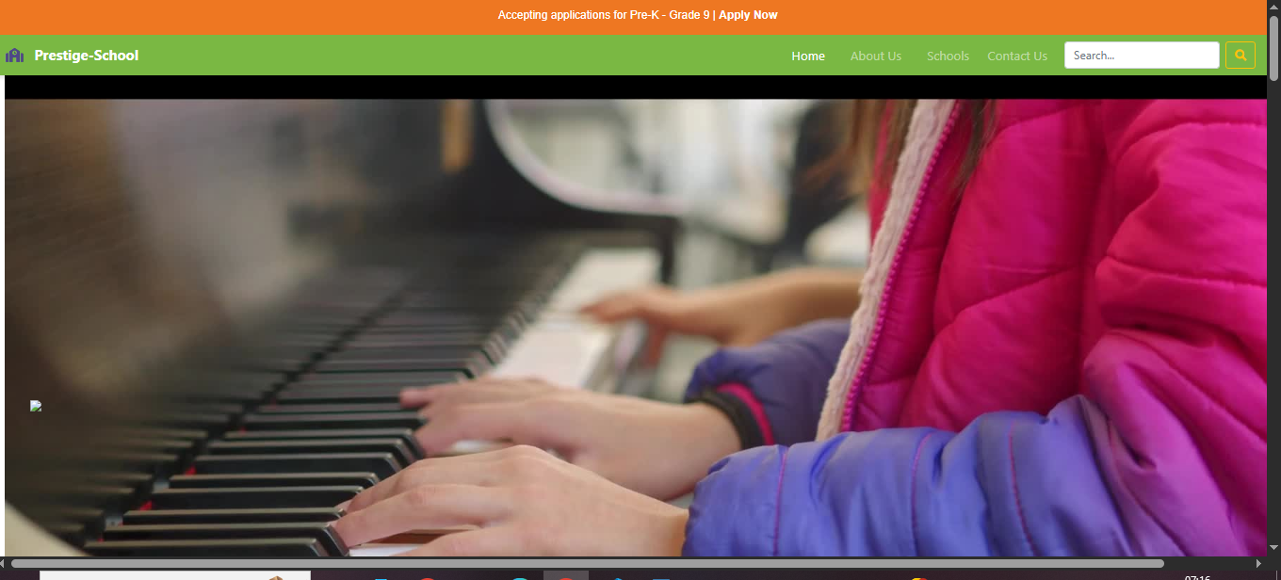

Special Activities



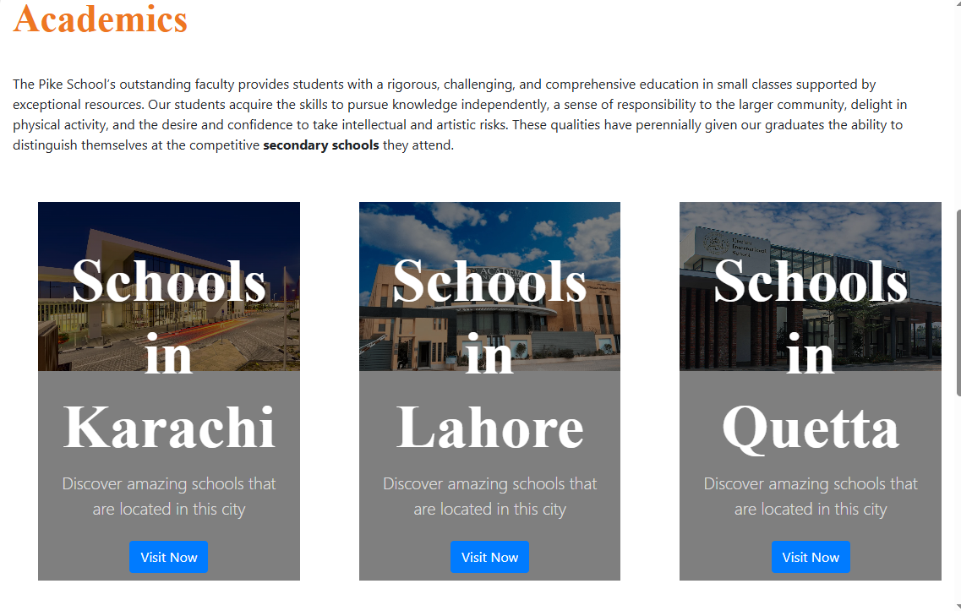Cards Section

Meet Our Team



Footer

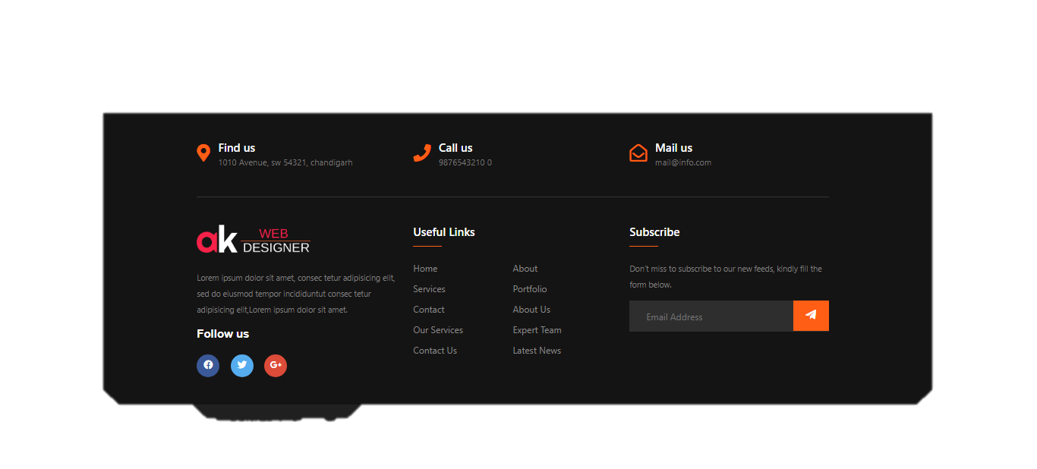

**About us Page**

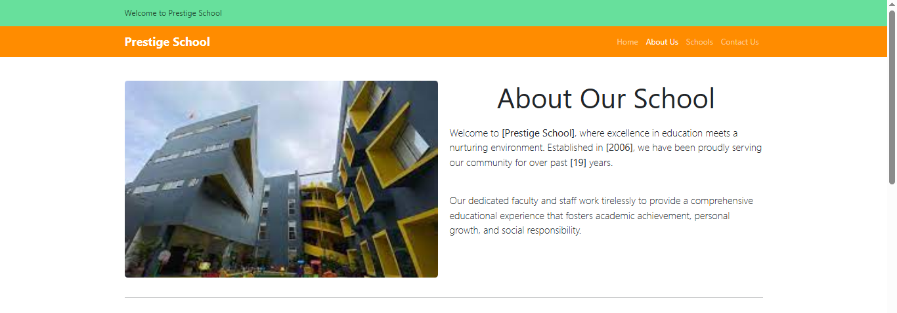

Our Goals and Vision

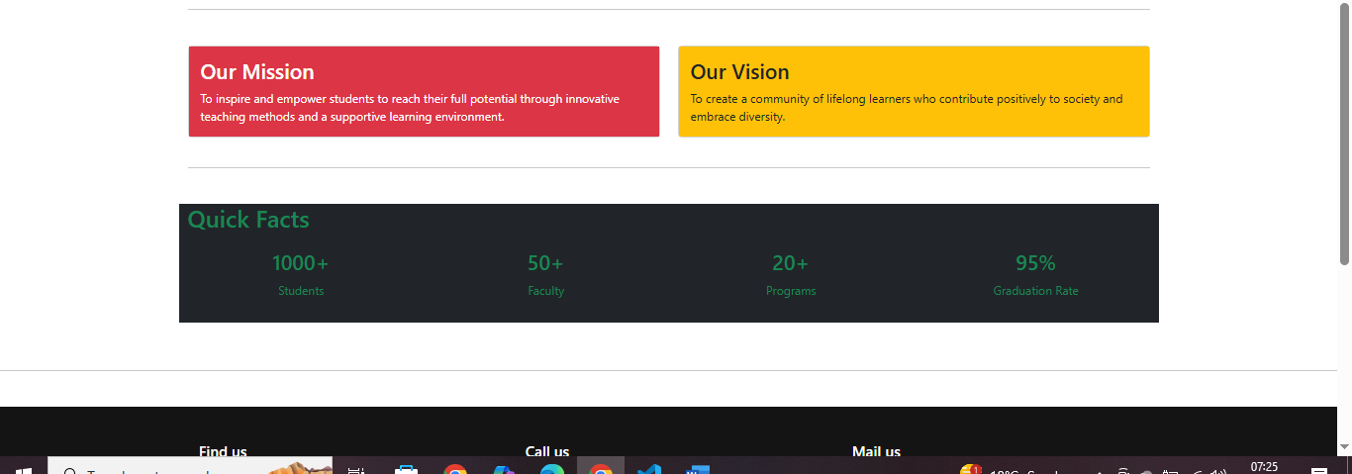

**Schools Page**

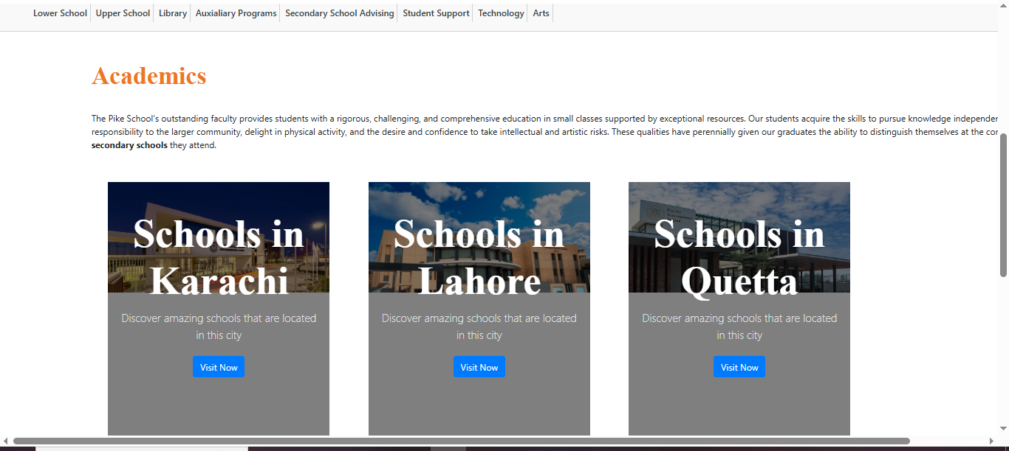

Schools in Karachi

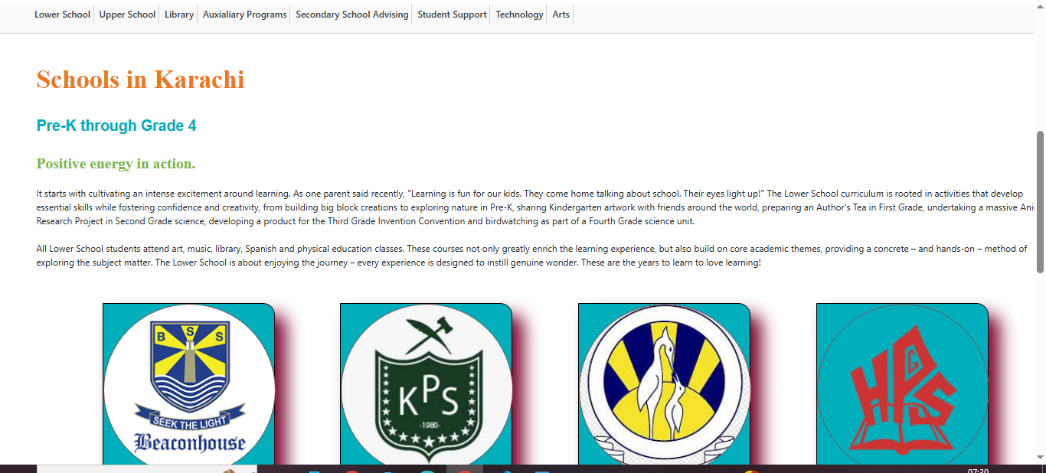

**Contact us Page**

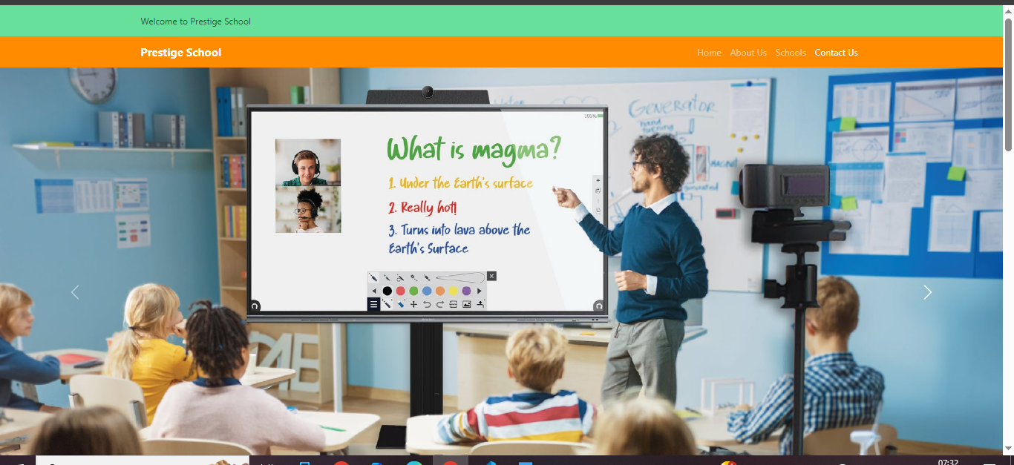

Contact us Form

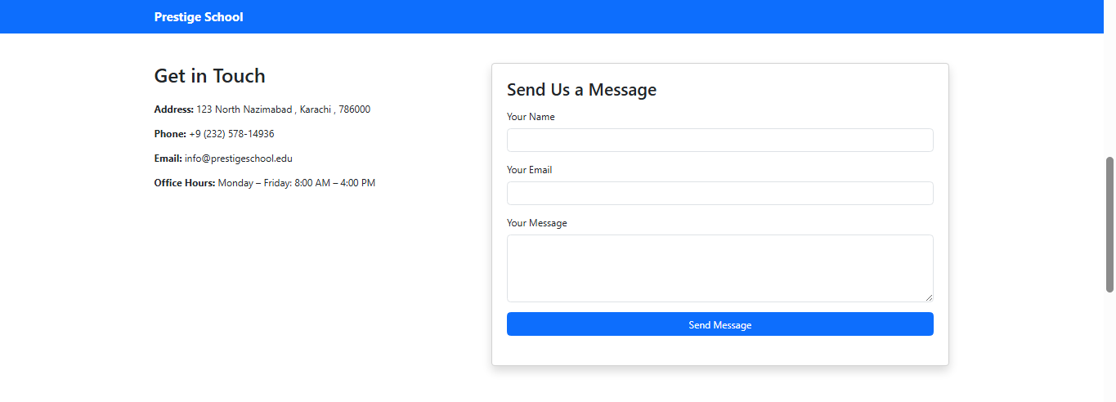

Find us Here (Maps)

